

# Lab

# Nested Loops

# Lab Objectives

In this lab we will go through a set of problems with nested loops.

# Tasks

1. Print a 5 by 7 box of ‘*’s.
2. Write a program that prints the following pattern:

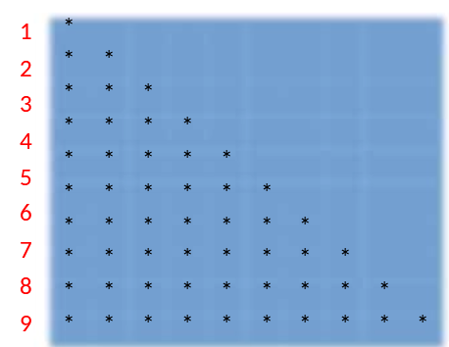

1. Create a program where every person meets the other  
   persons = [ “John”, “Marissa”, “Pete”, “Dayton” ]
2. Create a function that receives a list of commands (strings) and a list of files – and executes each command on each file.